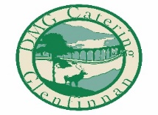
Glenfinnan Station Dining Car
Breakfast menu served 8.30am-10.45am

Traditional Scottish Porridge finished with cream
Porridge with Berries & Honey
Pancakes, Bacon & Maple syrup
Pancakes, Berries & Nutella
Hot smoked Salmon, scrambled egg and chives on a Scottish Farmhouse Scone
Full Scottish Breakfast (Lorne sausage, smoked bacon, black pudding, haggis, potato scone, tomato, mushrooms, fried egg, toast & butter)
Smoked Bacon & Scrambled eggs
Sauteed potatoes with spinach, tomato, mushrooms and avocado
Breakfast Roll (includes 1 filling), choose from bacon, beef lorne sausage, black pudding, haggis, potato scone, fried egg, mushrooms, avocado
Extra filling (each)
Portion of toast & butter
Portion of homemade jam OR marmalade
£5.00
£7.50
£9.95
£9.95
£13.95

£13.95

£9.50
£12.50

£4.50

£2.00
£2.00
£1.50

